Planning and Community Development
200 First Street Northeast
Moultrie, Georgia 31768

Phone (229) 668-7223 Fax (229) 668-7650

Residential Plan Submittal Application

Submit two sets of construction documents along with your application.

Additional construction Review Document Fees may be required for those structures defined in Title 25, Chapter 2, Section 25-2-13(b) of the Official Code of Georgia Annotated. Any additional fees will be determined at time of review and payment such additional fees will be required at the time plans are picked up.

Please type or print application

Date:_____________ Project Name:____________________ Zoning:_______________

Address of Project: ________________________________________________________________________
(Complete address with street number required to process application)

Name of Contact Person: ________________________ Phone: __________________

Address: ________________________________________________________________

Name of Owner of Project: __________________________ Phone: _________________

Address: ________________________________________________________________

TOTAL SQUARE FOOTAGE OF THIS PROJECT: ___________________________________

Building Type: _______________________ Valuation: $_____________________

NOTE: New construction or additions: A Level 1-A soil erosion card is required to pull a building permit along with a ticket number from the Utilities Protection Center of Georgia (UPCG). The “Call Before You Dig” phone number is 811.
Example (00000-000-000) Ticket Number: ______________________

Office Use Only
Plan Review Fee, for each submittal minimum fee $25.00 or (0.12%) of Total Valuation

Date Received: ______________________ Project Number: ______________________

Receipt # for Payment________ (make a copy of the check at the bottom or on the back of this application)
Copy Check

RESIDENTIAL PLAN SUBMITTAL REQUIREMENTS
To include but not limited to:

NEW CONSTRUCTION / ADDITIONS / EXTENSIVE RENOVATIONS

Project Address: __________________________________________________________

Applicant Signature: _______________________________________________________

Check off everything that is included in your set of plans:

- ____ Two sets of drawings

- ____ Thumb drive of plans in .pdf format

- ____ Site address

- ____ Site plan including existing and new structures, all set-backs measurements from property lines, and lot corners and buildings must be staked.

- ____ Foundation

- ____ Elevations

- ____ Electrical (Phase, Voltage, Amps, Underground, Overhead, Location of
Panel Box, etc.)

- ____ Plumbing

- ____ Mechanical

Note: Plans can only be accepted when all of the above are checked or stamped “exception noted” (EN), by our department. An attached exception noted email from our office may be substituted for the exception noted stamp.
If something is checked in error and/or the item is not included, this will cease review until you retrieve your plans and make necessary changes and/or additions. Please help us expedite your project plans by providing complete information.
A permit must be issued before work may begin. This includes, but is not limited to: building, electrical, plumbing, and HVAC.

NO FREEHAND DRAWINGS WILL BE ACCEPTED.
DRAWINGS ARE NEEDED FOR
NEW CONSTRUCTION, ADDITIONS AND ACCESSORY BUILDING(S).

CITY OF MOULTRIE
UTILITY SERVICES REQUEST

This page is required to be complete with your plan submittal

Date:___________________

Customer: ____________________________________________________________

Project Address:________________________________________________________

Contact Name: ________________________________________________________

Phone: _______________________________________________________________

ELECTRIC ____ Yes ____ No

New/Existing ____ Overhead ____ Underground

________ Phase
________ Voltage
________ Amperage/Kva

Comments:___________________________________________________
____________________________________________________________

GAS ____Yes ____No

New/Existing ________Size

Comments: ______________________________________________________________
________________________________________________________________________

WATER ____ Yes _____No

New/Existing __________Size

Comments: ______________________________________________________________
________________________________________________________________________

SEWER ____ Yes _____No

New/Existing

Comments: ________________________________________________________________________________________________________________________________________________

Requested By: _______________________________________________

Planning and Community Development
200 First Street Northeast
Moultrie, Georgia 31768
Phone (229) 668-7223 Fax (229) 668-7650

RESIDENTIAL PROJECTS PLAN SUBMITTAL REQUIREMENTS

Construction documents maybe mailed to the above address accompanied by the department’s plan submittal application. Construction documents require review prior to a permit being issued. Additional
Construction Review Document Fees may be required for those structures defined in Title 25, Chapter 2,
Section 25-2-13 (b) of the Official Code of Georgia Annotated. Any additional plan review fees will be determined at time of review and payment of such additional fees will be required at time plans are picked up.

The City of Moultrie offers plan review as a service to the community.

NEW CONSTRUCTION / ADDITIONS / EXTENSIVE RENOVATIONS

Construction documents shall include the following:

- Site plan shall indicate all buildings existing and new located on same property
- Type of construction of all buildings and distance between buildings

Foundation
Front, rear and side elevations
Elevations indicating height of building
Floor plans identifying use of each room or space
Door & Window schedules (to include tempered applications)

- Electrical panel schedule, smoke detector layout
- Plumbing riser diagram and fixture schedule
- Mechanical line diagram and schedule

The information contained in the plan submittal list is general in nature and does not preclude additional information being required on a project. Also, small renovations or tenant development in existing structures may not require an extensive plan submittal as contained in the submittal list to be determined by the authority having jurisdiction.

Codes currently enforced by the Department as adopted by the State, with Georgia Amendments:

2018 International Building Code
2018 International Residential Code
2018 International Fuel Gas Code
2018 International Mechanical Code
2018 International Plumbing Code
2018 International Energy Conservation Code
2018 International Swimming Pool and Spa Code
2018 International Fire Code
2018 International Property Maintenance Code
2010 Edition of the ADA Design Standards
2013 NFPA 72 National Fire Alarm code
2013 NFPA 13 Sprinkler Code
1996 NFPA 54 Gas Code
2017 National Electrical Code
2012 NFPA-101 Life Safety Code

2011 NFPA 96 Ventilation Control and Fire Protection of Commercial Cooking Operations
2015 International Swimming Pool Code

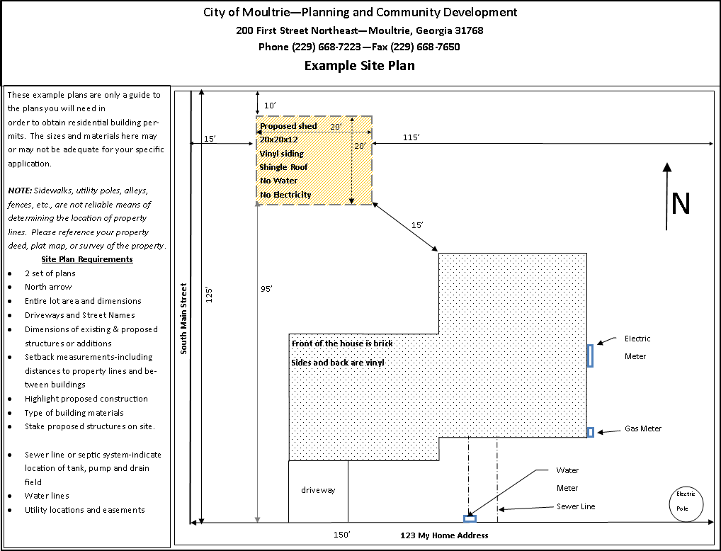

RESIDENTIAL INSPECTIONS

The General Contractor Must Notify Our Office For The
Certificate of Occupancy Inspection Before the Building Is Occupied

RESPONSIBILITIES OF PERMIT HOLDERS:

- Please give 24 hours prior notification when requesting inspections.
- Post field copy on site in a conspicuous place prior to commencing work.
- Comply with all applicable local, state and federal laws, codes, rules, regulations, etc.
- Request applicable required inspections:

MINIMUM REQUIRED INSPECTIONS:
Building
- Footing/slab – before concrete is placed.
- Framing – after all rough-in plumbing, electrical and mechanical is in place.
- Insulation: after baffles and insulation is installed and before installing gypsum board.
- Final (SFD) – after all building, mechanical, plumbing, gas and electrical systems are installed, connected and tested.
Plumbing
- Underground piping – after piping is installed and before backfill is placed 10 FT of head or 5 lbs of pressure.
- Rough-in – after soil, waste and vent, water supply and fuel piping are in place and before piping is concealed.
- Final – after all piping and fixtures are in place, connected and test.
NOTE: See Section 311 IPC for required test.
- Sewer & Water connect.
Mechanical
- Underground – after fuel and refrigerant piping is installed and before backfill is placed.
- Rough-in – after all fuel and refrigerant piping is in place and before piping is concealed and before any fixtures or appliances are connected.
- Final – after all piping, fixtures and appliances are installed, connected and tested.
Gas
- Underground – after all piping is installed and before backfill is placed.
- Rough-in – after piping is installed and before piping is concealed and before any fixtures or appliances are connected. This inspection shall include a pressure test.
- Final – after all piping, fixtures and appliances are installed, connected and tested.
Electrical
- Underground – after conduits are installed and before backfill is placed.
- Slab rough-in – after all electrical systems are installed prior to placement of concrete.
- Rough-in – after all wiring, conduit and boxes are installed prior to concealment. Exterior disconnect required.
- Final – after entire system is installed, connected and ready for testing.

Low Voltage
- Rough-in – after all wiring is installed or prior to concealment.
- Final – after all low-voltage systems are in place, connected and ready for testing.

ALL INSPECTIONS CAN BE SCHEDULED WITH THE
PLANNING AND COMMUNITY DEVELOPMENT DEPARTMENT
AT 229-668-7223

