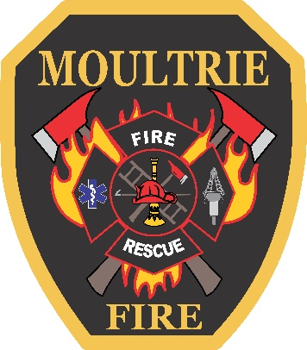
CITY OF MOULTRIE
JOB ANNOUNCEMENT

Position: Firefighter
Department: Fire/Suppression
Starting Salary: $35,000 (additional $2,000 for EMT certification)
Date: March 17, 2022

GENERAL NATURE OF WORK:
This position will respond to emergencies such as Fire calls, Medical calls, Haz-Mat calls, and or Rescue calls. Perform firefighting duties on fires, such as combating and extinguishing fires, rescue, ventilation, salvage and overhaul procedures. This position will provide basic first responder procedures while responding on medical calls such as CPR and defibrillation. Conduct rescue operations involving, but not limited to vehicles, high/low angle, confined space, structural collapse and trench. This position must participate in daily, weekly, monthly and annual training. This position must perform daily, weekly, monthly station, equipment and apparatus maintenance.

PHYSICAL REQUIREMENTS:
The employee in this position must be able to lift, pull or move up to 50 lbs. Ability to climb stairs, ladders and work with large and small objects. This position requires work outdoors, indoors, and possible exposure to changing weather, adverse smells, adverse conditions, sights, loud sounds and repetitive operations.

SALARY ENHANCEMENTS:
NPQ Certified Firefighters I through the Georgia Firefighters Standards and Training Council, who have successfully completed an Associates or Bachelor’s degree in a Fire Science/Administrative, Public/ Business Administration, and/or related fields, from an accrediting institution, are eligible for a salary enhancement.

QUALIFICATIONS:
Must be 18 years of age and must possess a high school diploma or equivalent, must possess a valid driver’s license and must satisfactorily complete the required criminal background check, pre-employment physical and drug test.

If you feel you qualify for this position, please report to the Human Resources Office to indicate your interest. Position will remain open until filled

